Use-Case Realization Report (Analysis)
View Cylinder Information

Issue <1.0>
Revision History
Date | Issue | Description | Author
<29/apr/11> | <1.0> | Initial Document | Koh Ming Jin

Table of Contents
1. Brief Description 4
2. Flow of Events 4
2.1 Standard Flow 4
2.2 Exception 4
3. Interaction Diagrams 4
3.1 Collaboration Diagram for View Cylinder Information 4
4. Participating Objects 4
4.1 View Cylinder Information Page 4
4.2 Cylinder Controller 4
4.3 Cylinder 4
5. Class Diagrams 5
5.1 Domain Class Diagram: View Cylinder Information 5
6. Derived Requirements 5

Use-Case Realization Report
View Cylinder Information

Brief Description
This use case enables an operation manager to view a cylinder information record.

Flow of Events
The standard flow of events for this use case and any exceptions are described in the following subsections. See section 3.1 for an overview of the participating Actors and Domain Objects.

Standard Flow
The flow of events is described as follows:

- The use case starts when Operation Manager selects the View Cylinder Information option of the system.
- The View Cylinder Information Page, which includes all the Cylinder Information details, is displayed.
- The Operation Manager can click on the cylinder ID to view more details about the particular cylinder.
- The use case terminates.

Exception
- NIL

Interaction Diagrams

Collaboration Diagram for View Cylinder Information
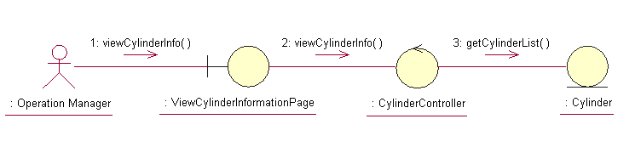

Participating Objects

View Cylinder Information Page
This object renders the contents to allow authorized actors to view Cylinder information. The Director, Department Manager and Operation Manager actors use this object.

Cylinder Controller
This object acts as the middleman between “View Cylinder Information” Page and the Cylinder object. It will translate interactions with the view into actions to be performed by the Cylinder object.

Cylinder
This object stores the details concerning the cylinder information of the COMS.

Class Diagrams

Domain Class Diagram: View Cylinder Information
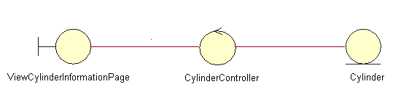

Derived Requirements
The Operation Manager PC keyboard and mouse will be used to retrieve Cylinder Information details (if any) and view all the system responses.

